Math 9: “Algebra Dude Art” SUBTRACTION Assignment Due: next class

Your job is to make your own “Algebra Dude” and “Algebra Object” (some object for your Algebra Dude). You will be subtracting the object from your Algebra Dude and figuring out the resulting polynomial expression. Your assignment will be marked by your peers.

Creating your Algebra Dude and Algebra Object:

Get algebra tiles, a mini dry-erase board, and a dry-erase marker.

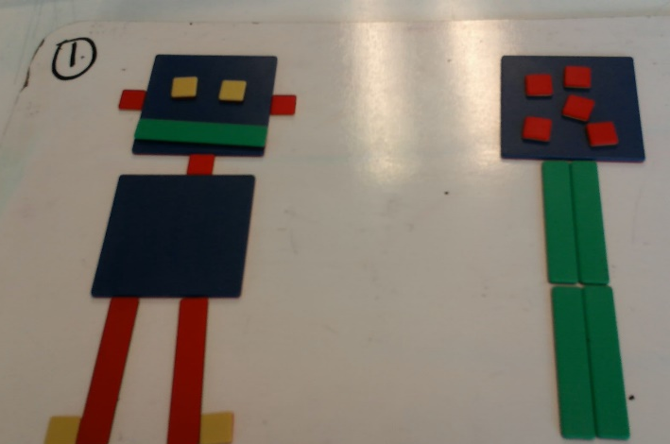
Using algebra tiles, design your own “Algebra Dude” (or “Algebra Girl” or “Algebra Robot” or “Algebra Art”) using algebra tiles. See next page for the list of criteria.

Using more tiles, create an “Algebra Object” for your “Algebra Dude.” For example, maybe he/she/they wants a cellphone, a car, a flower, etc.

Take a picture (Photo 1) of your two creations (try to get them in the same photo.)

Subtraction: “Algebra Dude” minus “Algebra Object”

Simplify Algebra Dude: Simply the expression for Algebra Dude by rearranging the tiles in it and removing zero pairs. Write the simplified expression on the whiteboard.

Simplify Algebra Object: Simply the expression for Algebra Object by rearranging the tiles in it and removing zero pairs. Write the simplified expression on the whiteboard.

Subtraction: draw a “minus” sign between Algebra Dude and Algebra Object. Take a picture (Photo 2). Make sure it shows the tiles in each simplified expression and the corresponding written expressions.

SUBTRACTION MEANS ADD THE OPPOSITE:

Change the “minus” sign to a “plus sign” and flip over all the tiles in the 2nd expression.

Write the new “flipped” expression. (For example, if your Algebra Object was 5x² – 3x + 2, the new expression that you get when you flip each term to the opposite sign is -5x² + 3x + (-2).

Take a picture (Photo 3). Make sure it shows all the tiles, the expression for Algebra Dude, and the new expression for Algebra Object.

Simplify: Rearrange the tiles so that like terms are together. Make sure that any tiles that form zero pairs are CLEARLY beside each other. Use the dry-erase marker to draw an arrow from each circle to show that we can remove the zero pair but don’t remove them yet! Take a picture (Photo 4).

Physically remove the zero pairs: What is the simplified expression that remains? Write it on the white board.

What type of polynomial are you left with (monomial, binomial, or trinomial)? Write it next to your simplified expression

Take a picture (Photo 5). Make sure the photo shows your final simplified polynomial expression (it is a difference), and the type of polynomial.

Getting a hard copy of the photos:

Email the 5 photos to yourself.

Login to a computer and open up a word or google docs document.

Login to your email. Copy and paste Photos 1 to 5 into the documents so that 2 photos fit per 1 page.

Write your name on the criteria side of this sheet and staple it to your art (so that the criteria sheet is on top as the 1st page). Hand it in! A peer will mark your assignment.

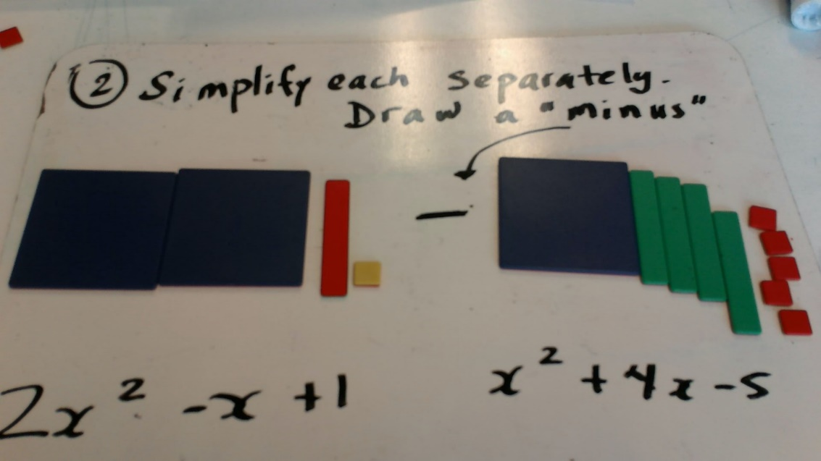
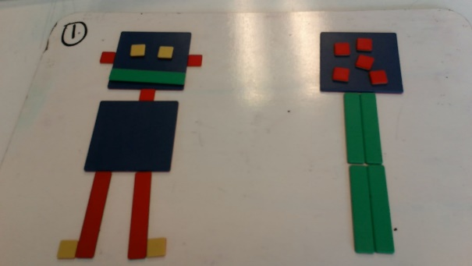
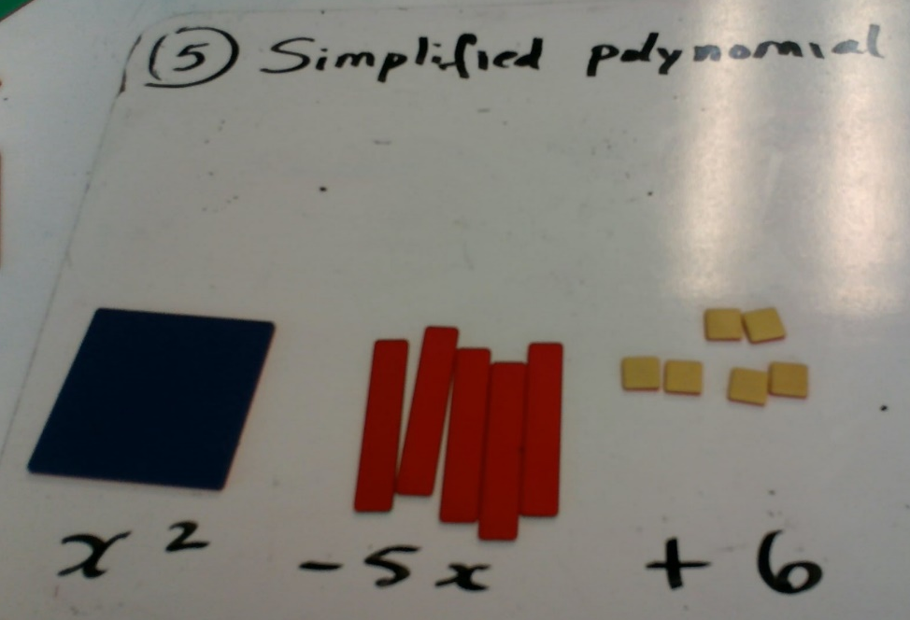
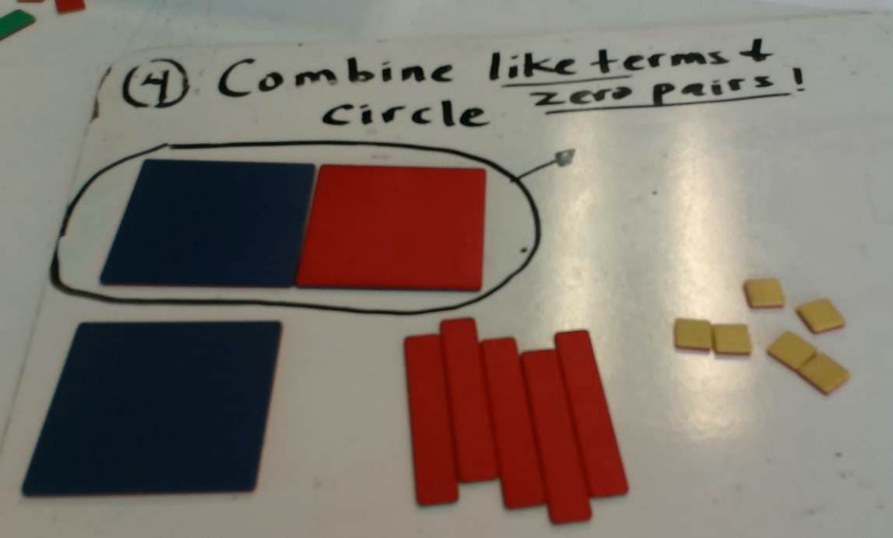
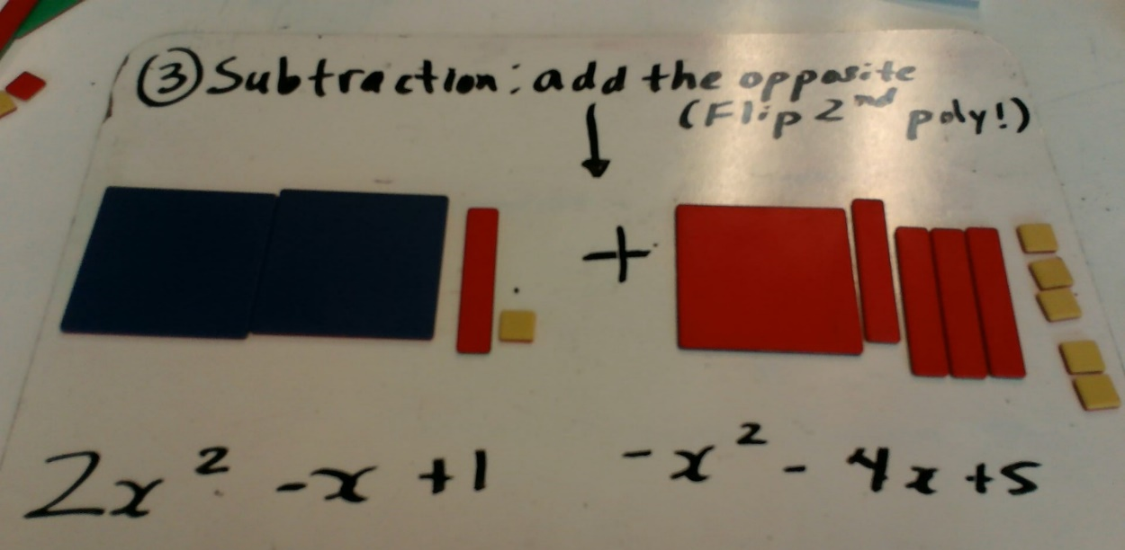

Math 9: “Algebra Dude Art” SUBTRACTION Assignment Criteria
Criteria | Max Points | Score
Algebra Dude uses tiles of each size | 1
Algebra Object uses tiles of each size | 1
Positive and Negative tiles are used | 1
Photo 1: Algebra Dude, Algebra Object | 5 (2.5 for Algebra Dude, 2.5 for Algebra Object)
Photo 2: Algebra Dude and Algebra object, simplified, with minus sign in between | 11:  5 for photo  1 point if coefficient for x² term is correct for Algebra Dude  1 point if coefficient for x term is correct for Algebra Dude  1 point if constant is correct for Algebra Dude  1 point if coefficient for x² term is correct for Algebra Object  1 point if coefficient for x term is correct for Algebra Object  1 point if constant is correct for Algebra Object
Photo 3: Algebra Dude + “opposite of Algebra Object” | 12:  5 for photo  1 point for plus sign (instead of minus)  3 points for flipping all of the tiles in Algebra Object  1 point if coefficient for x² term is correct for “opposite of Algebra Object”  1 point if coefficient for x term is correct for “opposite of Algebra Object”  1 point if constant is correct “opposite of Algebra Object”
Photo 4: Zero pairs circled | 6:  5 for photo  1 point for showing all zero pairs
Photo 5: Answer, simplified | 8 (This is the final answer to the subtraction):  5 for photo  1 point if coefficient for x² term is correct  1 point if coefficient for x term is correct  1 point if constant is correct
Type of polynomial | 2 for correctly identifying monomial, binomial or trinomial
Total: | 47
 | Your score as a percentage (divide score by 47 and multiply by 100) is:

Marked by: ____________________ (print your name)

Constructive feedback for the artist: _____________________________________________

___________________________________________________________________________

