**TRIANGLES**

* The lower case letter corresponding to the opposite vertex represents the length of the side.
* The side’s length can also be represented by its endpoints, BC.

**A**

B

C

**θ**

***x*°**

***a***

Capital letters at vertices.

* ∠A is the angle.
* A is the angle’s measure.

**Triangle Properties**

* sum of angles = 180°
* longest side is opposite the largest angle; shortest side is opposite the smallest angle
* In right triangles: *Pythagorean Theorem*, $a^{2}+b^{2}=c^{2}$.

Ex. 1: Identify the HYPOTENUSE (hyp), ADJACENT (adj), and OPPOSITE (opp) sides in each triangle:

**θ**



**θ**

**θ**



**PRIMARY TRIGONOMETRIC RATIOS**

In right triangles: sine of angle θ, **sin** θ  =  

**θ**

side **adjacent** to θ

side **opposite** θ

**hypotenuse**

cosine of angle θ, **cos** θ  =  

tangent of angle θ, **tan** θ  =  

**CALCULATOR USE**: Be sure your calculator is in **DEGREE MODE** !

***Determining the trigonometric ratio value of a given angle***

cos 50°: ∴ cos 50° ≈ 0.6428

***Determining the angle measure from a given trigonometric value***

sin θ = 0.75 ; θ = sin**−1** (0.75) ∴ θ ≈ 48.59°

Ex. 2: Evaluate each trigonometric ratio, to four decimal places.

1. cos 89° b) tan 42° c) sin 45°

Ex. 3: Find the angle given the trig ratio.

1. cos Ɵ = 0.1 b) tan Ɵ = 2.5

Ex.4: Determine the value of each trigonometric ratio. Express the answer as a fraction. Next, find the angle.

1. b) c)

tan A cos R sin Ɵ

cos C sin R tan $∠MLN$

**SOLVING RIGHT TRIANGLES**

When *solving triangles*, find **all** the unknown side lengths and angle measures.

Use triangle properties and trigonometry.

Ex. 5: In ΔABC; B = 90°, *b* = 15 cm, and *c* = 7 cm. Solve ΔABC. Answer to the nearest tenth of a degree or hundredth of a cm when necessary.

A

C

*b* = 15 cm

*c* = 7 cm

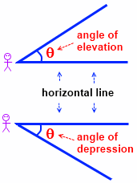

Ex. 6: From the top of a building, a surveyor determines the angle of depression of a parked car on the street below to be 34°. If the building is 28 m high, calculate the distance from the base of the building to the parked car. Answer to the nearest metre.

Practice

1 Given sin θ =  , determine the exact value of cos θ and of tan θ.

2 From the top of a cliff 110m high, an observer sees two boats, one directly behind the other, heading for shore. The angle of depression from the observer to the boat farther from the observer is 48° and the angle of depression to the nearer boat is 57°. Calculate the distance between the boats, to the nearest metre.

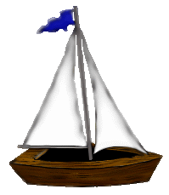

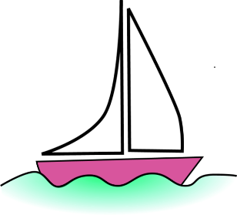

3 In ΔDEF; E = 90°, F = 25°, and DE = 6 m. Solve ΔDEF. Answer to nearest degree or tenth of a metre when necessary.

D

E

F

25°

  DE = 6 m

*Answers:*

1. cos θ =  & tan θ =  = . NOTE: It was not necessary to find the value of θ.
2. 28 m
3. D = 65° , DF ≈ 14.2 m , and EF ≈ 12.9 m

*Do not print:*

*Solution of 1*: For the given sine value, the right triangle it comes from could have a side opposite θ that is 3 units long and a hypotenuse that is 4 units long.

If so, then the length of the side adjacent to θ can be found using the Pythagorean Theorem. *x*2 + 32  =  42 ⎯→ *x*  =  

**θ**

4

3

*x*

Answer: cos θ =  and tan θ =  = 

NOTE: It was not necessary to find the value of θ.

*Solution of 3* Finding D: D = 180° − 90° − 25°  =  65°

Finding DF: sin 25° =  ⎯→ DF =   ≈ 14.2 m

Finding EF: tan 25° =  ⎯→ EF =    ≈ 12.9 m

Answer: D = 65° , DF ≈ 14.2 m , and EF ≈ 12.9 m

*Solution*: Draw a diagram and label all the given quantities. What do you need to find?

A

C

*b* = 15 cm

*c* = 7 cm

*a* = ? A = ? C = ?

**To find *a***: use the Pythagorean Theorem.

The hypotenuse is *b* !

*a*2 + *c*2 = *b*2 ⎯→ *a*2 + (7)2 = (15)2 ⎯→

*a*  =   =   =  4 ≈  13.27 cm

**To find A**: use *b*, *c*, and cosA

cos A = 

A =  cos−1

A ≈ 62.2°**To find ∠C**: use the sum of angles in a Δ

A  +  B  +  C =  180°

C =  180°  −  A  −  B

C ≈  180° − 62.2° − 90°

C ≈  27.8°

Answer: *a* ≈ 13.27 cm , A ≈ 62.2° , and C ≈ 27.8°

**1.** Solve each triangle. Round to the nearest tenth when appropriate.

**a)** **b)** **c)**

P

Q

R

21

27

G

H

K

55°

18

C

B

A

30 cm

18 cm

**2.** In ΔXYZ , ∠Y = 90° . Solve  ΔXYZ ; round to the nearest tenth when appropriate.

**a)** XY = 24 and XZ = 35 **b)** XZ = 72 and ∠Z = 52° **c)** YZ = 32 and ∠X = 64°

**3.** Find the measure of ∠A to the nearest degree if each value is   **a)**  sin A  and **b)**cos A

**(*i*)** 0.2079 **(*ii*)** 0.4384 **(*iii*)** 0.7431 **(*iv*)** 0.9063 **(*v*)** 0.9945

**4.** Write the **exact** values of sin A, cos A, and tan A for:

**a)** **b)**

A

15

8

17

A

53

28

45

**5.** Find the other two primary trigonometric ratios (exact values) of θ if:

**a)** sin θ  =   **b)** cos θ  =   **c)** tan θ  =  

**d)** tan θ  =   **e)** cos θ  =   **f)** sin θ  =  

**6.** The angle of depression from the top of a 20 metre tall lighthouse to a boat is 6°. How far from the lighthouse is the boat? Round to the nearest hundredth of a metre.

Answers

**1. a)**  AB = 24 cm, ∠A ≈ 36.9°, ∠C ≈ 53.1° **b)**  PR ≈ 34.2, ∠P ≈ 37.9°, ∠R ≈ 52.1° **c)**  GK ≈ 12.6, HK ≈ 22.0, ∠H = 35°

**2. a)**  YZ ≈ 25.5, ∠X ≈ 46.7°, ∠Z ≈ 43.3° **b)**  XY ≈ 56.7, YZ ≈ 44.3, ∠X = 38° **c)**  XY ≈ 15.6, XZ ≈ 35.6, ∠Z = 26°

**3. a)**  12°, 26°, 48°, 65°, 84° **b)**  78°, 64°, 42°, 25°, 6°

**4. a)**  sinA = , cosA = , tanA =  **b)**  sinA = , cosA = , tanA = 

**5. a)**  cosθ = , tanθ =  **b)**  sinθ = , tanθ =  **c)**  sinθ = , cosθ =  **d)**  sinθ = , cosθ =  **e)**  sinθ = , tanθ =  **f)**  cosθ = , cosθ = 

**6.** 190.29 m

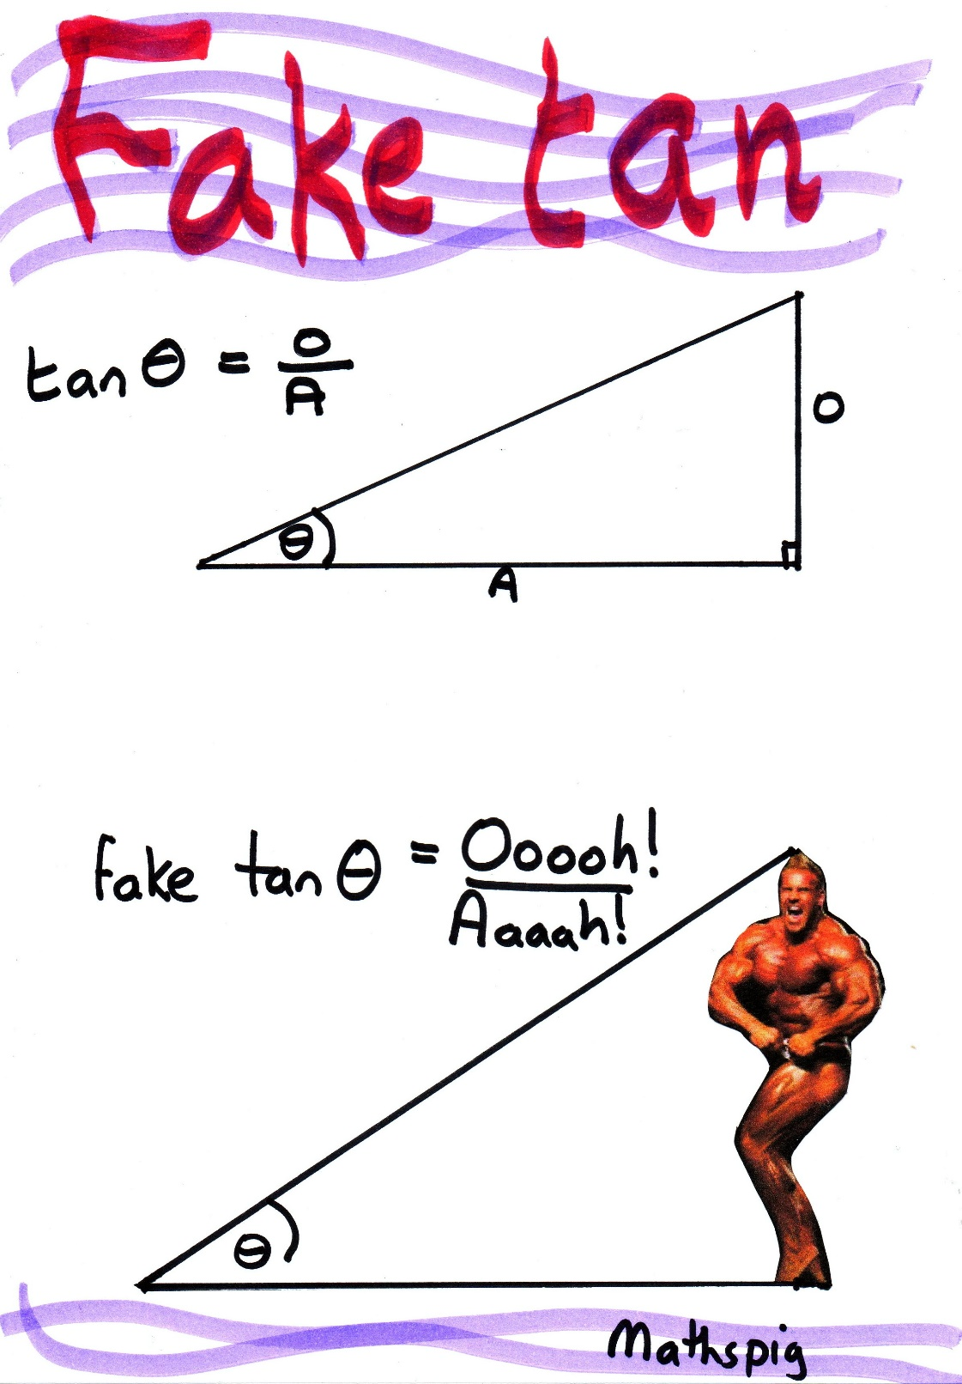

DO NOT PRINT:

5

4

3

θ

10

8

6

θ

20

16

12

θ

**Similar Triangles**

* corresponding angles are congruent
* corresponding sides are proportional

 =  = 

 =  = 

 =  = 