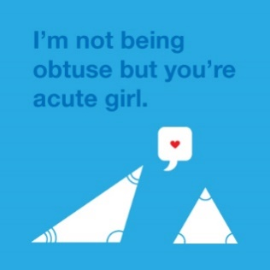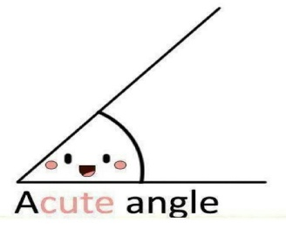An ***oblique triangle*** is a non-right triangle; it could be *acute* or *obtuse*.



In an ***acute triangle*** all the angles are less than 90°.



In an ***obtuse triangle*** one of the angles is greater than 90°.



**THE SINE LAW**



B

C

A

D

*h*

*b*

*a*



Consider the oblique triangle ΔABC with side lengths *a*, *b*, and *c*.

Draw an altitude of height *h* from vertex C to point D.



There are now two right triangles, ΔACD and ΔBCD.



• In ΔACD • In ΔBCD

C

D

B

*h*

*a*

A

C

D

*h*

*b*

sin A =  sin B =  



*b* (sin A) =  *h* *a* (sin B) =  *h*

*h* =  *b* sin A *h* =  *a* sin B



• Since both equal *h*. *b* sin A =  *a* sin B • Similarly:

Divide both sides by *ab*.  =    =  



Simplify both sides.  =   and  =  



***The Sine Law*** can be used with any ΔABC:



There are two cases when the Sine Law can be used, when the given information is:

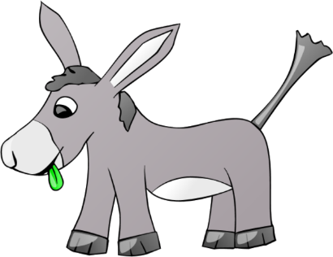CASE 1: CASE 2:



**CASE 1: GIVEN TWO ANGLES AND A SIDE (AAS or ASA)**



Ex. 1: In ΔABC, ∠B = 115°, ∠C = 23°, and *b* = 14.5 cm. Find *a* to the nearest hundredth of a centimetre.



*a* = **?**

115°

B

C

A

23°

*b* = 14.5 cm



Steps:



* Draw a labelled diagram.



* A known angle-side pair is needed; ∠B and *b*.



* To find side length *a*, ∠A is needed.



* Use Sine Law with A, *a*, B, and *b*.



* Substitute the known angles and sides.



* Solve for *a*.



Ex. 2: In ΔJKL, ∠J = 30°, ∠L = 40°, *l* = 8 m. Find *j* to 2 decimal places. [Answer: 6.22 m]



**CASE 2: GIVEN TWO SIDES AND A NON-INCLUDED ANGLE (SSA)**

Ex. 3: In ΔDEF, ∠D = 52°, *d* = 102, and *e* = 83. Find ∠E to the nearest degree.



*e* = 83

F

D

E

52°

**?**

*d* = 102



[Answer: ∠E ≈  39.883 14° or  40°]

Ex. 4: In ΔRST, ∠R = 120°, *r* = 6 m, *s* = 4 m. Find ∠S to 1 decimal place. [Answer: 35.3°]



HW after problems at boards: p. 108, #1-3, 4bcd, 5, 10, 12, 13, 15.

Boards:

1. In $∆PQR$, find the length of QR to the nearest tenth of a centimetre.



[Answer: 8.6 cm]

1. In $∆GHJ,$ find $∠G$ to the nearest degree. Hint: Find $∠G first.$



DO NOT PRINT:



solution: In ΔABC, ∠B = 115°, ∠C = 23°, and *b* = 14.5 cm. Find *a* to the nearest hundredth of a centimetre.

* Draw a labelled diagram.
* A known angle-side pair is needed; ∠B and *b*.
* To find side length *a*, ∠A is needed. A  +   B    +   C   =  180°

A  + 115° + 23° =  180°

A =  42°

* Use the formula with A, *a*, B, and *b*.  =  

Substitute the known angles and sides.  =  

Solve for *a*. *a* =  

*a* ≈  10.705 41

Answer: *a* ≈  10.71 cm