Foundations of Math and PreCalculus 11

2022-2023 Course Outline

Teacher: Ms. M. Kamber Email: Micheline.Kamber@burnabyschools.ca
Room: A201 Website: mkamber.weebly.com
Phone: 604.296.6880 ext 605126 YouTube: tinyurl.com/mathmadnessmedia

Course Information

Foundations of Mathematics 11 is a pathway designed to provide students with the mathematical understandings and critical-thinking skills identified for entry into post-secondary studies in programs (e.g., business, arts, music, and nursing) that do not require the study of theoretical calculus.
Topics of Study

- Factoring Polynomials (Review)
- Quadratic Functions & Equations (Ch 7)
- Geometry (Ch 2)
- Inductive & Deductive Reasoning (Ch 1)
- Statistical Reasoning (Ch 5)
- Financial Literacy (new curriculum: not in textbook!)
- Proportional Reasoning (Ch 8)
- Systems of Linear Equations and Linear Inequalities (Ch 6)

Course Evaluation

Term Mark: 80% Tests
10% Quizzes
10% Assignments

Final Mark: 90% Course Work
** Subject to change 10% Final Exam

Course Materials

Textbook: You will not need a textbook! I will provide Notes Booklets and Assignments Booklets for each Unit. You are only entitled to 1 copy of each.

School supplies: - Scientific calculator (cell-phone calculators not permitted. Calculators cannot be shared).
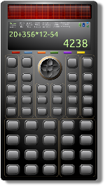
- Binder
- Lined paper
- Pencils*, eraser, ruler, highlighters (different colours are useful)
- Dry-erase markers (recommended to have your own)
Assignments count for marks!
- Assignments: Each class, there is a math assignment to help you practice and develop understanding.
- Label each assignment: For each assignment, write “Day 1” or “Day 2”, etc.
- “The answer doesn’t matter. Communicating how you got the answer matters!”
- If you copy the answer without showing your work, be prepared to be able to explain to me how you solved those problems in order to get credit.
- You are responsible: It is YOUR responsibility to complete the assignments, check your work, and ask questions about anything you don’t understand. Remember, the more you practice, the stronger the neural connections you’ll make!
- If absent, you are still responsible: You are responsible for work assigned on days you were absent. If absent, check with a classmate and/or my website (mkamber.weebly.com) for assigned work.
- Assignments due: All assignments are due on the day of the Unit Test (at start of class). For your assignments to be counted, you must already have filled out the Assignment Cover Page Self-Assessment. Late assignments will not be accepted.
- This course moves quickly: You cannot put off the homework for a specific topic and still expect to be able to move on with the next lesson.

What is Math Madness?!? This is a designated time when you are encouraged to come for help and work on your assignments! We meet in my classroom (Flex Time 8:40-9:10, or to 9:20 on Fridays). Stay as long as you like.

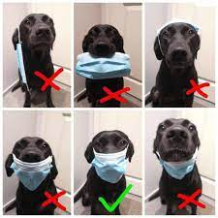
Expectations
- Masks are welcome: Keep you, your family, and the families of those around you safe!
- RESPECT people, property, and yourself.
- Behave maturely towards everyone in the class.
- Work hard and be kind. Be prepared to work with others and for changes in seating.
- Keep a growth mindset. (Believe in your math abilities!)
- Keep cell phones and listening devices away unless instructed by the teacher.
- We do math (& puzzles) for the whole block!
- If you are absent, you must bring a valid note from a parent/guardian. Students are expected to check their assignments package for details of assigned work and to be up-to-date on material when they return.
- Use class time wisely to complete work and ask for permission if you need to leave the room and return as soon as possible.
- Try your best but ask for help. Come to Math Madness and/or make an appointment to see me during lunch or after school.

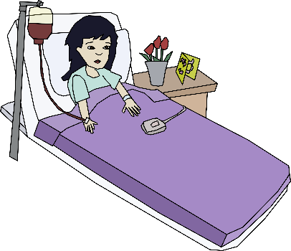
Policy on Absences for Unit Tests
- If a student knows that they will be absent on the day of an upcoming test, they must make prior arrangements with the teacher to write the test at another time.
- If a student misses a unit test, a parent or guardian must phone or email the teacher on the day of the test, excusing the student from the test on that day. A day to write the test will be arranged.
- If all other cases, students will have to wait for a make-up day towards the end of the term to write the test.
- Being nervous or unprepared for a test is not a valid reason for absence on the day of the test.

Honesty Policy and Test-Taking Procedure

- Cell phones at the front of the class.
- Be prepared for assigned seating.
- No electronic devices.
- No talking or communication with classmates.
- No notes or extra paper.
- Eyes on your own paper.
- No sharing of supplies/information.
- Put your hand up if you have a question.
- Bring your silent reading book for when you're done or try a puzzle.
10. Cheating = 0 plus meeting with your parents/guardians.

Burnaby South Secondary School’s Honesty Policy in outlined in your Student Planner.

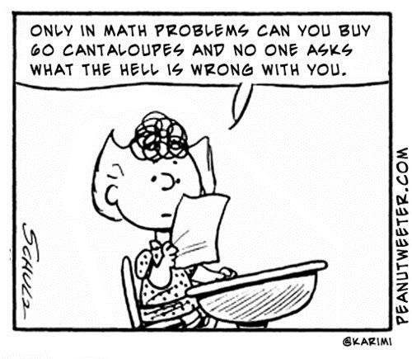

Keeping Track of My Marks

Unit | Quizzes | Unit Test | Assignments
Quadratic Functions & Equations (Ch 7)

Geometry (Ch 2)

Inductive & Deductive Reasoning (Ch 1)

Statistical Reasoning (Ch 5)

Proportional Reasoning (Ch 8)

Financial Literacy
Systems of Linear Equations & Linear Inequalities (Ch 6)

