Math 9

2018-2019 Course Outline

Teacher: Ms. M. Kamber Email: Micheline.Kamber@burnabyschools.ca
Room: G206 Website: mkamber.weebly.com
Telephone: 604-296-6880 ext. 605217

Course Information

Welcome to Math 9! Math is a common human activity, which is done throughout life. Everyone, we can see how important math is in rapidly advancing areas such as technology, science, and business. This course is designed to give you a greater proficiency in mathematics and will increase opportunities that are available to you, as an individual, and to even help you get rich!

Topics

- Exponents (Ch 2)  - Rational Numbers (Ch 3)  - Probability and Statistics (Ch 9)  - Linear Relations (Ch 4)  - Polynomials (Ch 5) | - Linear Equations and Inequalities (Ch 6)  - Financial Literacy  - Scale, Maps, and Similar Triangles (Ch 7)  - Puzzles and Games (throughout the year)
Course Evaluation

Term Mark: 75% Tests
10% Quizzes
15% Assignments, Booklets, Journaling, Binder Check
** Subject to change

Final Mark: 90% Terms 1, 2, and 3 will be weighed equally
10% Final Exam

Course Materials

Textbook: Math Makes Sense 9 – Pearson
Student binder with: Lined paper for notes in a binder
Graph paper*
1 Folder* (to hand in homework)
2 dividers (Notes and Homework)

Stationary supplies: pencils*, eraser, ruler, highlighters (different colours are useful)

Scientific calculator*: cell-phone calculators not permitted
Assignments count for marks!
- Assignments: Each class, there is a math assignment (usually some questions from the textbook or a separate worksheet) that will help you practice and develop understanding.
- Label each assignment: For each assignment, write the Unit Day, Topic, Section number, page number, and assigned date (e.g., Day 1, What is a Power?, Sec. 2.1, p. 55, Sept. 12).
- Honor your thinking: All work and calculations must be shown.
- You are responsible: It is your responsibility to complete the assignments, check your work, and ask questions about anything you don’t understand. Remember, the more you practice, the stronger the neural connections you’ll make!
- If absent, you are still responsible: You are responsible for work assigned on days you were absent. If absent, check with a classmate and/or my website (mkamber.weebly.com) for assigned work.
- Assignments due: All assignments are due on the day of the Unit Test (at start of class) in a folder. For your assignments to be counted, you must already have filled out your Assignment Self-Assessment. Late assignments will not be accepted.
- This course moves quickly: You cannot put off the homework for a specific topic and still expect to be able to move on with the next lesson.

What is Math Madness?!? This is a designated time when you are encouraged to come for help and cookies! We meet in my classroom at 3:10 to 4:45, typically on Wednesdays (on the 3rd week of every month, we will meet on Tuesdays.) Stay as long as you like. Sessions are held weekly. Check the classroom notices for the exact dates.

Expectations

- Be RESPECTFUL and behave maturely towards everyone in the class.
- Work hard and be kind.
- Keep a growth mindset. (Believe in your math abilities!)
- Keep cell phones away unless instructed by the teacher.
- We do math for the whole block!
- If you are absent, you must bring a valid note from a parent/guardian. Students are expected to check my website (mkamber.weebly.com) for details of assigned work and to be up-to-date on material when they return.
- Be prepared to work with others and for changes in seating.
- Try your best but ask for help. Come to Math Madness and/or make an appointment to see me during lunch or after school.

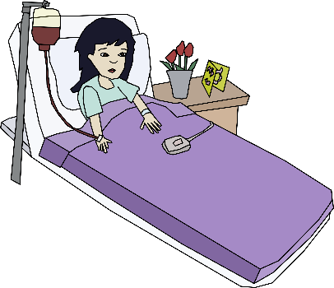
Policy on Absences for Unit Tests
- If a student knows that he/she will be absent on the day of an upcoming test, he/she must make prior arrangements with the teacher to write the test at another time.
- If a student misses a unit test, a parent or guardian must phone or email the teacher on the day of the test, excusing the student from the test on that day. A day to re-write will be arranged.
- If all other cases, students will have to wait for a make-up day towards the end of the term to write the test.

Honesty Policy and Test-Taking Procedure

- Backpacks, jackets, and cell phones at the front of the class.
- Be prepared for assigned seating.
- No electronic devices.
- No talking or communication with classmates.
- No notes or extra paper.
- Eyes on your own paper.
- No sharing of supplies/information.
- Put your hand up if you have a question.
- Bring your silent reading book for when you're done.
10.The classroom can be cold! Bring a sweater but leave jackets up front.

Burnaby South Secondary School’s Honesty Policy in outlined in your Student Planner.

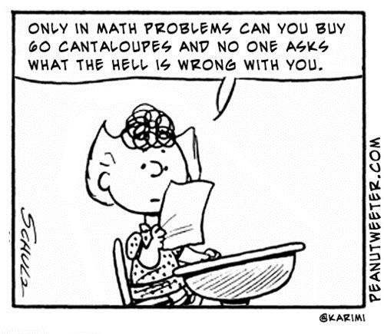

Keeping Track of My Marks

Unit | Quizzes | Unit Test | Assignments, Booklets, Journaling, Binder Check
Exponents (Ch 2)

Rational Numbers (Ch 3)

Probability and Statistics (Ch 9)

Linear Relations (Ch 4)

Polynomials (Ch 5)

Linear Equations and Inequalities (Ch 6)

Financial Literacy

Scale, Maps, and Similar Triangles (Ch 7)

