Math 9

2021-2022 Course Outline

Teacher: Ms. M. Kamber Email: Micheline.Kamber@burnabyschools.ca
Room: A201 Website: mkamber.weebly.com
Phone: 604.296.6880 ext 605126 YouTube: tinyurl.com/mathmadnessmedia

Course Information

Welcome to Math 9! Math is a skill for everyday life! Math is in rapidly advancing areas such as technology, science, and business. This course is designed to give you a greater proficiency in mathematics to prepare you for higher level math courses. Math 9 will increase opportunities that are available to you, as an individual, and our financial literacy unit can even help you get rich!

Topics

- Exponents (Ch 2)  - Rational Numbers (Ch 3)  - Probability and Statistics (Ch 9)  - Polynomials (Ch 5)  - Algebra: Linear Equations (Ch 6) | - Linear Relations (Ch 4)  - Scale, Maps, and Similar Triangles (Ch 7)  - Financial Literacy (not in textbook)  - Puzzles and Games (throughout the year)

Course Evaluation

Term Mark: 75% Tests
15% Quizzes
10% Assignments, Journaling

Course Materials

Textbook: Math Makes Sense 9 – Pearson

School supplies: - Calculator (cell-phone calculators not permitted. Calculators cannot be shared).
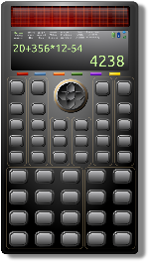
- Journal, e.g., a thin notebook or dollar-store journal
- Binder with Lined paper
- Pencils*, eraser, ruler, highlighters (different colours are useful)
- Graph paper (may be needed towards the end of course)

- Dry-erase markers (recommended to have your own)
Assignments count for marks!
- Assignments: Each class, there is a math assignment to help you practice and develop understanding.
- Label each assignment: For each assignment, write the “Day 1” or “Day 2”, etc.
- “The answer doesn’t matter. Communicating how you got the answer matters!”
- If you copy the answer without showing your work, be prepared to be able to explain to me how you solved those problems in order to get credit.
- You are responsible: It is YOUR responsibility to complete assignments, check your work, and ask questions about anything you don’t understand. Remember, the more you practice, the stronger the neural connections you’ll make!
- If absent, you are still responsible: You are responsible for work assigned on days you were absent. If absent, check with a classmate and/or my website (mkamber.weebly.com) for assigned work.
- Assignments due: All assignments are due on the day of the Unit Test (at start of class). For your assignments to be counted, you must already have filled out your Assignment Self-Assessment. Late assignments will not be accepted.
- This course moves quickly: You cannot put off the homework for a specific topic and still expect to be able to move on with the next lesson.

What is Math Madness?!? This is a designated time when you are encouraged to come for help and cookies and work on your assignments! We meet in my classroom before first block. Stay as long as you like.

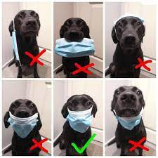
Expectations
- Wear a mask to keep your, your family, and the families of those around you safe!
- RESPECT people, property, and yourself.
- Behave maturely towards everyone in the class.
- Work hard and be kind. Be prepared to work with others and for changes in seating.
- Keep a growth mindset. (Believe in your math abilities!)
- Keep cell phones and listening devices away unless instructed by the teacher.
- We do math (& puzzles) for the whole block!
- If you are absent, you must bring a valid note from a parent/guardian. Students are expected to check their assignments package for details of assigned work and to be up-to-date on material when they return.
- Use class time wisely to complete work and ask for permission if you need to leave the room and return as soon as possible.
- Try your best but ask for help. Come to Math Madness and/or make an appointment to see me during lunch or after school.

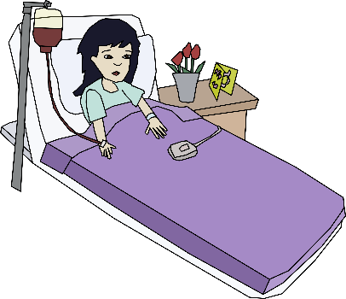
Policy on Absences for Unit Tests
- If a student knows that he/she will be absent on the day of an upcoming test, he/she must make prior arrangements with the teacher to write the test at another time.
- If a student misses a unit test, a parent or guardian must phone or email the teacher on the day of the test, excusing the student from the test on that day. A day to write the test will be arranged.
- If all other cases, students will have to wait for a make-up day towards the end of the term to write the test.
- Being nervous or unprepared for a test is not a valid reason for absence on the day of the test.

Honesty Policy and Test-Taking Procedure

- Cell phones at the front of the class.
- Be prepared for assigned seating.
- No electronic devices.
- No talking or communication with classmates.
- No notes or extra paper.
- Eyes on your own paper.
- No sharing of supplies/information.
- Put your hand up if you have a question.
- Bring your silent reading book for when you're done or try a puzzle.
10. Cheating = 0 plus meeting with your parents/guardians.

Burnaby South Secondary School’s Honesty Policy in outlined in your Student Planner.

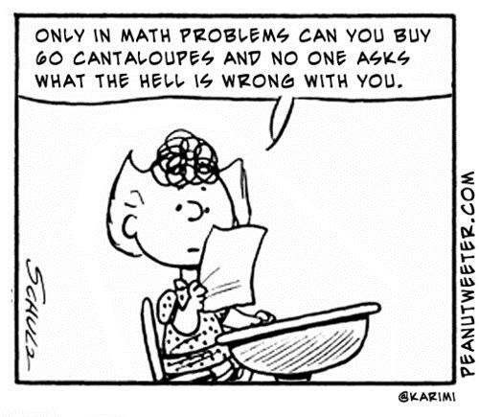

Assessment

The BC Ministry of Education is moving to a Standards-Based Grading (SBG) system that assesses students’ level of mastery on various learning goals or standards.

The Learning Goals:

Content & Calculations (Content)

Reasoning and Analyzing (RA)

Understanding and Solving (US)

Communicating and Representing (CmRp)

Connecting and Reflecting (CnRf)

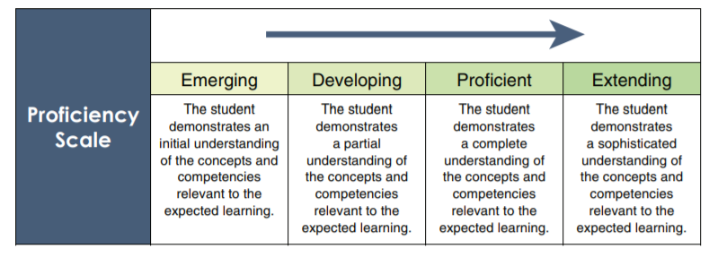
Instead of assigning just one mark for a test, the learning outcomes are assessed individually using a 4-point proficiency scale. In this way, students receive more specific feedback on their progress in each area. The Ministry’s 4-point scale is:

No overall percentage will be assigned in this course. However, a description of the student’s level of understanding for each learning outcome will be provided at the end of each unit.

