Math 9

2022-2023 Course Outline

Teacher: Ms. M. Kamber Email: Micheline.Kamber@burnabyschools.ca
Room: A201 Website: mkamber.weebly.com
Phone: 604.296.6880 ext 605126 YouTube: tinyurl.com/mathmadnessmedia

Course Information

Welcome to Math 9! Math is a skill for everyday life! Math is in rapidly advancing areas such as technology, science, and business. This course is designed to give you a greater proficiency in mathematics to prepare you for higher level math courses. Math 9 will increase opportunities that are available to you, as an individual, and our financial literacy unit can even help you get rich!

Topics

- Exponents (Ch 2)  - Rational Numbers (Ch 3)  - Probability and Statistics (Ch 9)  - Polynomials (Ch 5)  - Algebra: Linear Equations (Ch 6) | - Linear Relations (Ch 4)  - Scale, Maps, and Similar Triangles (Ch 7)  - Financial Literacy (not in textbook)  - Puzzles and Games (throughout the year)

Course Materials

Textbook: Math Makes Sense 9 – Pearson

School supplies: - Calculator (cell-phone calculators not permitted. Calculators cannot be shared).
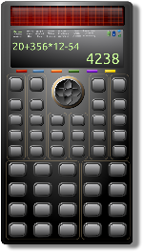
- Journal, e.g., a thin notebook or dollar-store journal
- Binder with Lined paper
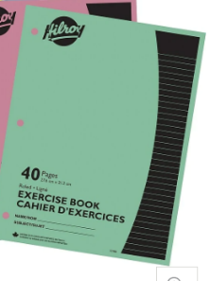
- Pencils*, eraser, ruler, highlighters (different colours are useful)
- Dry-erase markers (recommended to have your own)

Assignments
- Assignments: Each class, there is a math assignment to help you practice and develop understanding.
- Label each assignment: For each assignment, write “Day 1” or “Day 2”, etc.
- “The answer doesn’t matter. Communicating how you got the answer matters!”
- If you copy the answer without showing your work, be prepared to be able to explain to me how you solved those problems in order to get credit.
- You are responsible: It is YOUR responsibility to complete assignments, check your work, and ask questions about anything you don’t understand. Remember, the more you practice, the stronger the neural connections you’ll make!
- If absent, you are still responsible: You are responsible for work assigned on days you were absent. If absent, check with a classmate and/or my website (mkamber.weebly.com) for assigned work.
- Assignments due: All assignments are due on the day of the Unit Test (at start of class). You must already have filled out your Assignment Cover Page Self-Assessment regarding how much work you did. Late assignments will not be accepted.
- This course moves quickly: You cannot put off the homework for a specific topic and still expect to be able to move on with the next lesson.

What is Math Madness?!? This is a designated time when you are encouraged to come for help and work on your assignments! We meet in my classroom (Flex Time 8:40-9:10, or to 9:20 on Fridays). Stay as long as you like.

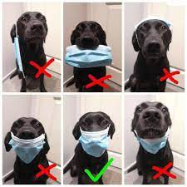
Expectations
- Masks are welcome: Keep you, your family, and the families of those around you safe!
- RESPECT people, property, and yourself.
- Behave maturely towards everyone in the class.
- Work hard and be kind. Be prepared to work with others and for changes in seating.
- Keep a growth mindset. (Believe in your math abilities!)
- Keep cell phones and listening devices away unless instructed by the teacher.
- We do math (& puzzles) for the whole block!
- If you are absent, you must bring a valid note from a parent/guardian. Students are expected to check their assignments package for details of assigned work and to be up-to-date on material when they return.
- Use class time wisely to complete work and ask for permission if you need to leave the room and return as soon as possible.
- Try your best but ask for help. Come to Math Madness and/or make an appointment to see me during lunch or after school.

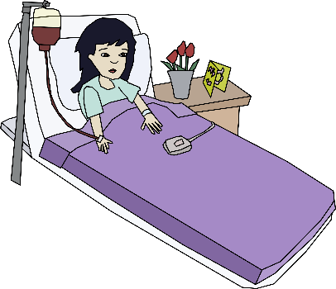
Policy on Absences for Unit Tests
- If a student knows that they will be absent on the day of an upcoming test, they must make prior arrangements with the teacher to write the test at another time.
- If a student misses a unit test, a parent or guardian must phone or email the teacher on the day of the test, excusing the student from the test on that day. A day to write the test will be arranged.
- If all other cases, students will have to wait for a make-up day towards the end of the term to write the test.
- Being nervous or unprepared for a test is not a valid reason for absence on the day of the test.

Honesty Policy and Test-Taking Procedure

- Cell phones at the front of the class.
- Be prepared for assigned seating.
- No electronic devices.
- No talking or communication with classmates.
- No notes or extra paper.
- Eyes on your own paper.
- No sharing of supplies/information.
- Put your hand up if you have a question.
- Bring your silent reading book for when you're done or try a puzzle.
10. Cheating = 0 plus meeting with your parents/guardians.

Burnaby South Secondary School’s Honesty Policy in outlined in your Student Planner.

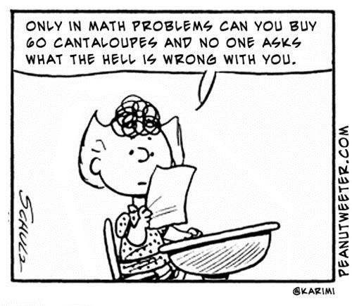

Assessment

The BC Ministry of Education is moving to a Standards-Based Grading (SBG) system that assesses students’ level of mastery on various learning goals or standards.

The Learning Goals:

Content & Calculations (Content)

Reasoning and Analyzing (RA)

Understanding and Solving (US)

Communicating and Representing (CM)

Connecting and Reflecting (CR)

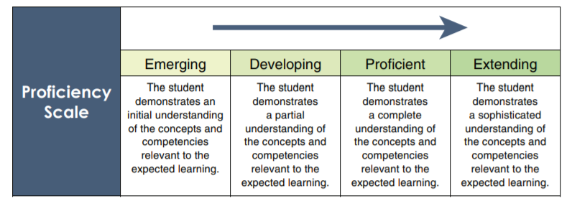
Instead of assigning just one mark for a test, the learning outcomes are assessed individually using a 4-point proficiency scale. In this way, students receive more specific feedback on their progress in each area. The Ministry’s 4-point scale is:

No overall percentage will be assigned in this course. However, a description of the student’s level of understanding for each learning outcome will be provided at the end of each unit.

