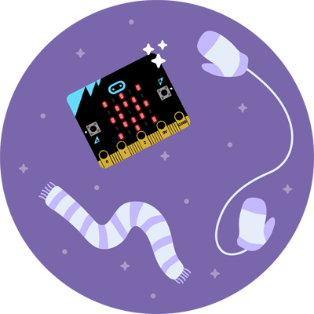
Microbits Coding Guide and Reflection

The step-by-step thinking required in math is also required in coding! Jobs in coding can earn you lots of money! (Check online to see how much the starting salary of a computer programmer is in BC.) Software developers are in demand. Coding also teaches you to not give up!
The coding platform is at: On my website (mkamber.weebly.com), I have a link to makecode.microbit.org (or just type “makecode microbit” to find their site).
Click on a tutorial and then follow the instructions. To start, do the Dice tutorial, then the Rock, Paper, Scissors one. (You can then challenge another group to a game of Rock, Paper, Scissors with your microbit!) Also try one of the holiday ones like the Snowglobe.
Instructions to download your code onto the microbit:
- Click “Download”
- Go do the Downloads folder on your computer and look for the microbit file you just created. It should be a “.hex” file.
- Drag or copy it onto “Microbit (D:)”
- Alternate instructions:
  - The filename may appear on the bottom left of the screen with an arrow (“^”) next to it. If so, click on the arrow.
  - Choose “Show in Folder”
  - Right click on the filename of microbit program and choose “Send to”
  - Choose “Microbit (D:)”

Before the end of class, complete the reflection on the back of this page…

Reflection
- What activities did you program attempt today? (List all.)

- Which activities did you complete?

- What was your mindset during the activity? Did you at any point become frustrated while coding or feel that you couldn’t figure it out? Did your mindset change at any point? Did you persevere? Explain.

- If you had a partner, who was your partner?

- How did you share the work? Who did what?

- Would you be interested more activities involving coding? Why or why not?

