

PRE-CALCULUS 11 Unit 1 – Day 2 and Day 3: FUNCTIONS REVIEW and QUADRATIC FUNCTIONS

# FUNCTIONS

A *relation* describes the relationship between the two quantities, *x* and *y*.



A relation can be defined by:



* an equation, *y* = *x*2 where *x*  R and 1  *x*  2



* a table of values • a ***mapping diagram*** • a set, { (1,1) , (0,0) , (1,1) , (2,4) }



|  |  |  |  |  |  |  |  |  |  |  |  |
| --- | --- | --- | --- | --- | --- | --- | --- | --- | --- | --- | --- |
| |  |  | | --- | --- | | *x* | *y* | | 1 | 1 | | 0 | 0 | | 1 | 1 | | 2 | 4 | | *x*      1    0    1    2    *y*    0    1    4 |

* a graph. *y*

1

4



1 0 1 2 *x*



The *domain* of a relation is the set of all the *x*-coordinates from the relation.



The *range* of a relation is the set of all the *y*-coordinates from the relation.



exercise: In the graph, domain =



exercise: In the graph, range =



exercise: Write the domain and range of each relation graphed using set notation and as intervals.



a)

b)

c)

(0

,

−

3)

(0

,

3)

(3

,

0)



A *function* is a special type of relation.

In a function, every *x*-value from the domain is paired with just one *y*-value.



function

*x*  *y* = *x*2  *y*



*x* = 2  *y* = 4



*x* = 2  *y* = 4



The *Vertical Line Test* for a Function.



All vertical lines crosses this graph at



(2,4) (2,4) only 1 point, so



*y*

*x*

every *x*-value will be paired with a single *y*-value.



A relation is not a function if there is an *x*-value that is paired with more than one *y*-value.

not a function *y* = 2

1. = 4  *x* = *y*2



1. = 2



*y*

*x*

(4

,

2)

(4

,

−

2)

The vertical line crosses the graph at more than 1 point, so this *x*-value has 2 different *y*-values; this is not a function.



exercise: Which of the graphs shown at the bottom of the previous page are functions?



***Function Notation***

*f* (*x*) is “*f* of *x*” or “the value of function *f* for any given value of the variable *x*”.



Ex: *y*2*x*3 is equivalent to *f* *x*2*x*3 exercise: a) Determine *f* 4



b) Determine *x* if *f* *x*1



Function notation can be used to define a function for a question.



exercise: *f* (*x*) = *x*2  4 In this example the value of the function *f* for a given value of *x* is calculated by squaring the *x*-value and then subtracting 4.



exercise: *f* (3) = (3)2  4 = 5 *f* (0) =



*f* (1) = *f* (1) =



*f* (2) = *f* (½) =



# ZEROS OF FUNCTIONS 



The ***zeros of a function*** are the *x*-values for which the function value is 0 (y= 0). In other words; **the *x*intercepts.**



example: Determine the zero(s) of the function *f* (*x*) = *x*2  4



0 = *x*2  4



4 = *x*2



*x* = 2 or *x* = 2



The zeros of *f* (*x*) are 2 and 2.



Where would the zeros of this function appear on the graph of *y* = *f* (*x*) ?



exercise: Determine the zero(s) of the function *g*(*x*) = 2*x* + 9



# QUADRATIC FUNCTIONS

A ***quadratic function*** is a second degree function and can be written in its

* ***standard form***: *y* = *ax*2 + *bx* + *c*, where *a*, *b*, and *c* are real numbers and *a*  0, or



* ***vertex form***: *y* = *a*(*x*  *p*)2 + *q*, where *a*, *p*, and *q* are real numbers and *a*  0.



exercise: Which of the following functions are quadratic? Explain why.

* 1. *y* = *x*2  3*x*



* 1. *y* = 2*x* + 6

* 1. *y* = (*x* + 4)(2*x*  1)



* 1. *y* = (*x* + 7)2 + 5

* 1. *y* = (*x* + 2)(*x*  2)



# THE BASIC QUADRATIC FUNCTION AND ITS GRAPH

The equation of the basic quadratic function is *y* = *x*2 or *f* (*x*) = *x*2.

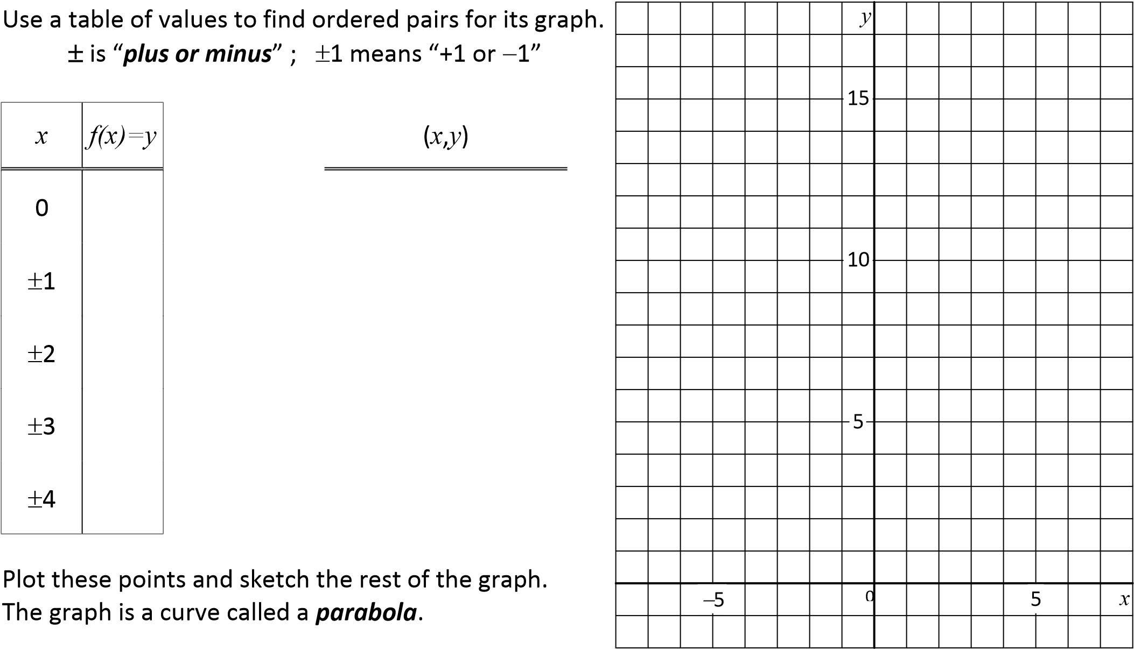

Parts of a Parabola ***vertex*** = axis of symmetry



equation of the ***axis of symmetry***:

***minimum value*** of this function:

***maximum value*** for this function:

domain =

vertex range =

Notice the difference between successive *y*-value from the table; how can this pattern be used to draw the graph of parabola quickly?



Graphing Calculator: Press Y = input Y1 = X2 or Y1 = X^2

Press Graph

## PRE-CALCULUS 11 Unit 1 – Day 2: Functions Review and Quadratic Functions Exercises

For each relation, **a)** write the domain and range

**b)** draw the relation as an arrow diagram

**1.** { (3,6) , (4,5) , (7,2) , (9,0) } **2.** { (3,3) , (0,0) , (3,3) }

For each arrow diagram, **a)** write the relation as a set of ordered pairs

**b)** write the domain and range

**3**

**.**

**4**

**.**

*x*

5

7

9

12

*y*

4

6

8

1

1

*x*

4

*y*

1

6

8

1

0

For each graph, **a)** express the relation as a set of ordered pairs

**b)** write the domain and range

**5**

**.**

**6**

**.**

2

−

2

0

−

2

*x*

*y*

2

*x*

*y*

0

2

−

2

−

2

2

Graph each relation. The domain is ***R***.

**7.** *y* = *x* + 5 **8.** *y* = 3*x*  4 **9.** *y* =  *x*

**10.** 3*x*  2*y* = 6 **11.** *y* = 3 **12.** *x* = 2

State whether each set of ordered pairs represents a function.

**13.** { (2,5) , (4,3) , (6,1) , (8,1) , (9,2) } **14.** { (3,2) , (5,6) , (6,8) , (3,2) , (6,4) }

**15.** { (2,3) , (2,2) , (2,1) , (2,0) , (2,1) } **16.** { (8,1) , (7,1) , (3,1) , (4,1) }

1. If *f*(*x*) = 2*x* + 3 , find
   1. *f*(4) **b)** *f*(8) **c)** *f*(0) **d)** *f*(1)

**e)** *f*(4) **f)** *f*(0.5) **g)** *f*(0.1) **h)** *f*(100)

1. If *f*(*x*) = 9  3*x* , find
   1. *f*(2) **b)** *f*(6) **c)** *f*(2) **d)** *f*(0)

**e)** *f*(5) **f)** *f*(0.1) **g)** *f*(0.2) **h)** *f*(10)

Graph each function. The domain is ***R***. Find the range of *g* .

1. *g*(*x*) = 4  2*x* **20.** *g*(*x*) = *x*2  1

*PRE-CALCULUS 11 Unit 1*  *Day 2: Functions Review and Quadratic Functions Exercises*

State whether each of the following is a graph of a function. Write the domain and range in each case.

**21**

**.**

**22**

**.**

*x*

*y*

0

2

−

2

−

2

2

*x*

*y*

0

2

−

2

−

2

2

Determine the zeros of the functions.

**23.** *h*(*x*) = *x* + 5 **24.** *h*(*x*) = 3*x*  4

1. Which functions are quadratic?

**a)** *y* = 3*x*2 + 7*x*  2 **b)** *f*(*x*) = *x*2 + *x* **c)** *f*(*x*) = 25  9*x*2

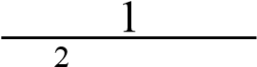 **d)** *y* = 7  5*x*2 **e)** *y* = 2*x*2 + 11  4*x* **f)** *f*(*x*) = 4*x*  9 12*x*

1. Given that *g*(*x*) = *x*2 and *y* = 2*g*(*x*  3)  8, determine *y* in terms of *x* , then simplify.

**ANSWERS**

1. **a)** domain = {3,4,7,9} , range = {0,2,5,6} **1.b)** *x* **2.b)** *x*

3

4

7

9

*y*

0

2

5

6

−

3

0

3

*y*

0

3

1. **a)** domain = {3,0,3} , range = {0,3} **3. a)** {(5,4),(7,4),(7,6),(7,8),(9,11),(12,11)}

**b)** domain = {5,7,9,12} , range = {4,6,8,11}

**4. a)** {(4,1),(4,6),(4,8),(4,10)} **b)** domain = {4} , range = {1,6,8,10}

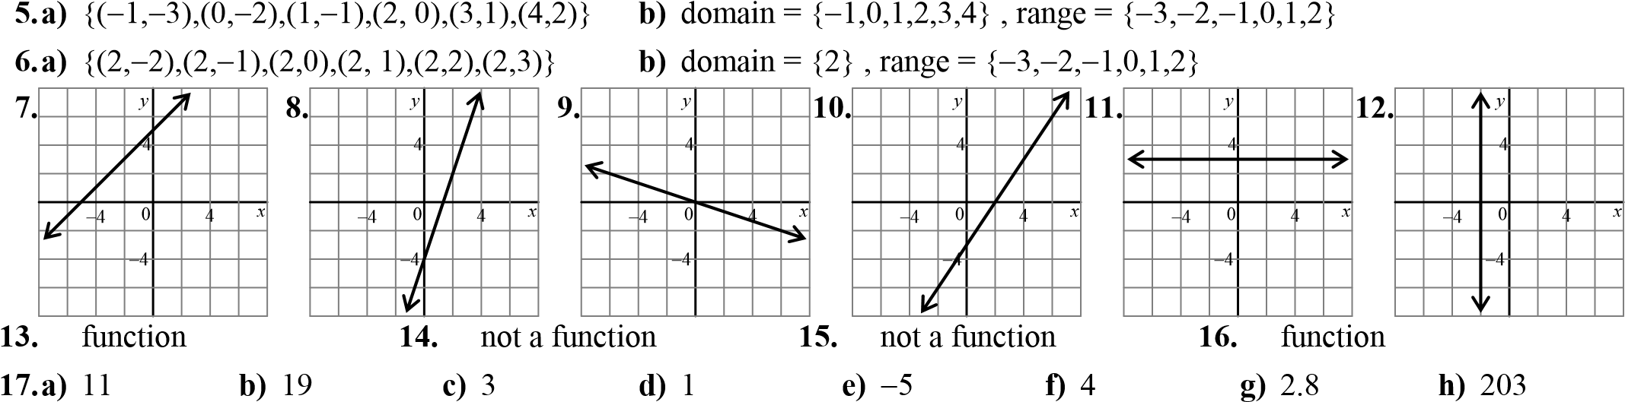

**18. a)** 3 **b)** 9 **c)** 15 **d)** 9 **e)** 24 **f)** 8.7 **g)** 9.6 **h)** 21

**19.**

**20.**

**21.**

function

domain

=

{

*x*



*x*



○

, range

}

=

{

*y*



*y*



−

3

,

*y*



○

}

**22**

**.**

not a function

domain

=

{

*x*



−

3



*x*



,

3

*x*



○

, range

}

=

{

*y*



−

3



*y*



,

3

*y*



○

}

{

*y*



*y*



○

}

{

*y*



*y*



−

,

1

*y*



○

}

*x*

*y*

0

4

−

4

−

4

4

*x*

*y*

0

4

2

−

2

2

**23.** 5 **24.**  **25.** a, c, d, e **26.** *y* = 2(*x*  3)2  8  *y* = 2*x*2  12*x* + 10