PRE-CALCULUS 11

2019-2020 Course Outline

Teacher: Ms. M. Kamber Email: Micheline.Kamber@burnabyschools.ca
Room: G206 Website: mkamber.weebly.com
Telephone: 604-296-6880 ext. 605217

Course Information

Pre-Calculus 11 is a challenging course that is designed to provide students with the mathematical understandings and critical-thinking skills identified for entry into post-secondary programs that require the study of theoretical calculus.
Students taking this course should have at least a final mark of 67% in Foundations of Mathematics and Pre-Calculus 10.

Topics of Study
- Polynomial Factoring  - Quadratic Functions (Ch 3)  - Quadratic Equations (Ch 4)  - Linear and Quadratic Inequalities (Ch 9)  - Real Number System  - Powers with Rational Exponents | - Radical Expressions and Equations (Ch 5)  - Rational Expressions and Equations (Ch 6)  - Trigonometry (Ch 2)  - Financial Literacy (new! Not in textbook)

Course Evaluation

Term Mark: 80% Tests
10% Quizzes
10% Assignments and Journaling
** Subject to change

Final Mark: 90% Terms 1, 2, and 3 will be weighed equally
10% Final Exam

Course Materials

Textbook: Pre-Calculus 11 – McGraw-Hill Ryerson
Journal*: e.g., a notebook or dollar-store journal
Student binder with: Lined paper for notes in a binder
Graph paper*
2 dividers (Notes and Homework)

Stationary supplies: pencil*, eraser, ruler, highlighters (different colours are useful)

Scientific calculator*: with sin, cos, tan buttons (cell-phone calculators not permitted)
Assignments count for marks!
- Assignments: Each class, there is a math assignment (usually some questions from the textbook or a separate worksheet) that will help you practice and develop understanding.
- Label each assignment: For each assignment, write the Unit Day, Topic, Section number, page number (e.g., Day 8, Completing the Square, Sec. 3.3, p. 192).
- Honor your thinking: All work and calculations must be shown.
- You are responsible: It is your responsibility to complete the assignments, check your work, and ask questions about anything you don’t understand. Remember, the more you practice, the stronger the neural connections you’ll make!
- If absent, you are still responsible: You are responsible for work assigned on days you were absent. If absent, check with a classmate and/or my website (mkamber.weebly.com) for assigned work.
- Assignments due: All assignments are due on the day of the Unit Test (at start of class). For your assignments to be counted, you must already have filled out your Assignment Self-Assessment. Late assignments will not be accepted.
- This course moves quickly: You cannot put off the homework for a specific topic and still expect to be able to move on with the next lesson.

What is Math Madness?!? This is a designated time when you are encouraged to come for help and cookies! We meet in my classroom at 3:10 to 4:45, typically on Wednesdays (on the 3rd week of every month, we will meet on Tuesdays.) Stay as long as you like. Sessions are held weekly. Check the classroom notices for the exact dates.

Expectations

- RESPECT people, property, and yourself.
- Behave maturely towards everyone in the class.
- Work hard and be kind. Be prepared to work with others and for changes in seating.
- Keep a growth mindset. (Believe in your math abilities!)
- Keep cell phones and listening devices away unless instructed by the teacher.
- We do math (& puzzles) for the whole block!
- If you are absent, you must bring a valid note from a parent/guardian. Students are expected to check my website (mkamber.weebly.com) for details of assigned work and to be up-to-date on material when they return.
- Use class time wisely to complete work and ask for permission if you need to leave the room and return as soon as possible.
- Try your best but ask for help. Come to Math Madness and/or make an appointment to see me during lunch or after school.

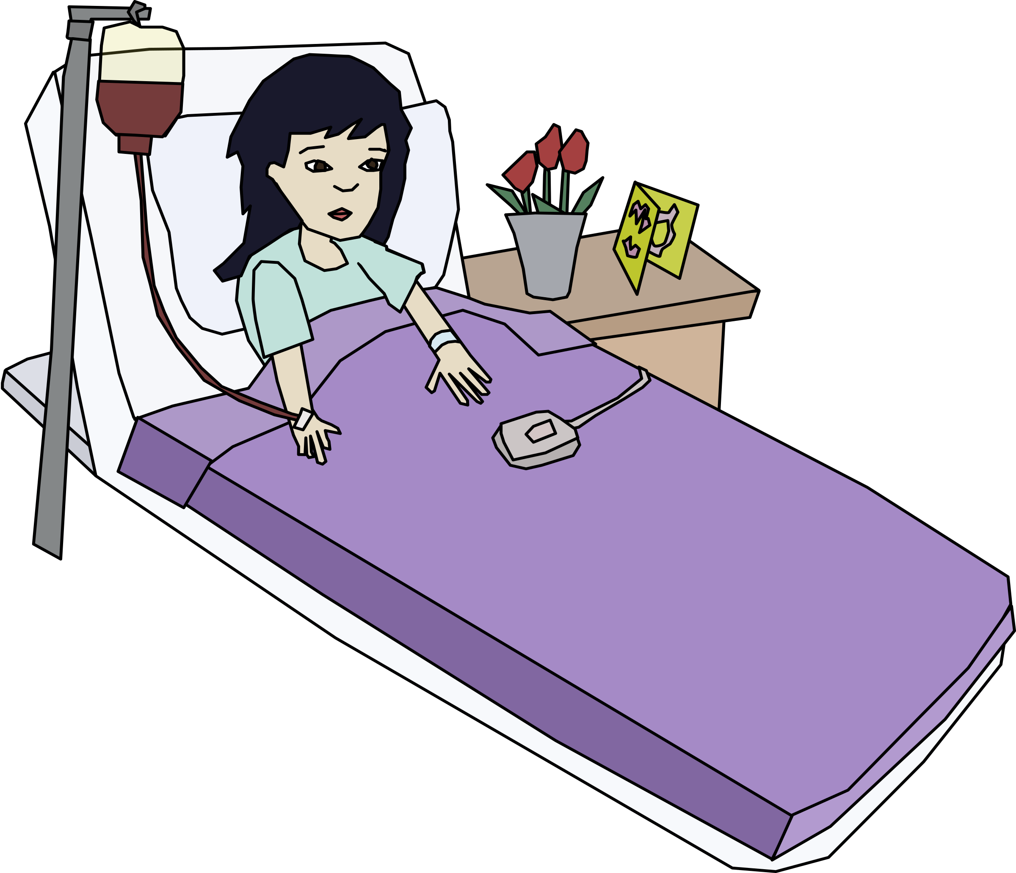Policy on Absences for Unit Tests
- If a student knows that he/she will be absent on the day of an upcoming test, he/she must make prior arrangements with the teacher to write the test at another time.
- If a student misses a unit test, a parent or guardian must phone or email the teacher on the day of the test, excusing the student from the test on that day. A day to re-write will be arranged.
- If all other cases, students will have to wait for a make-up day towards the end of the term to write the test.

Honesty Policy and Test-Taking Procedure

- Cell phones, jackets, and backpacks at the front of the class.
- Be prepared for assigned seating.
- No electronic devices.
- No talking or communication with classmates.
- No notes or extra paper.
- Eyes on your own paper.
- No sharing of supplies/information.
- Put your hand up if you have a question.
- Bring your silent reading book for when you're done.
10.The classroom can be cold! Bring a sweater but leave jackets up front.

Burnaby South Secondary School’s Honesty Policy in outlined in your Student Planner.

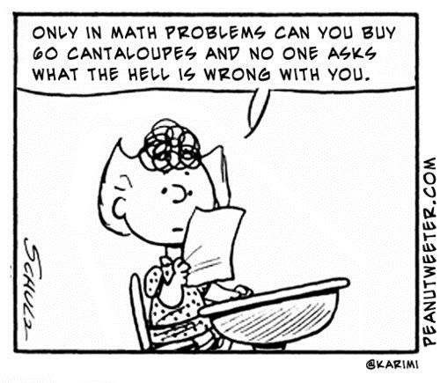

Keeping Track of My Marks

Unit | Quizzes | Unit Test | Assignments & Journaling
Quadratic Functions (Ch 3)

Quadratic Equations (Ch 4)

Linear and Quadratic Inequalities (Ch 9)

Radical Expressions and Equations (Ch 5)

Rational Expressions and Equations (Ch 6)

Trigonometry (Ch 2)

Financial Literacy

Term 1:
Term 2:
Term 3:
Final:

