PreCalculus 11

2023-2024 Course Outline

Teacher: Ms. M. Kamber Email: Micheline.Kamber@burnabyschools.ca
Room: A201 Website: mkamber.weebly.com
Phone: 604.296.6880 ext 605126 YouTube: tinyurl.com/mathmadnessmedia

Course Information

Pre-Calculus 11 is a challenging course that is designed to provide students with the mathematical understandings and critical-thinking skills identified for entry into post-secondary programs that require the study of theoretical calculus. It is recommended that students whose final mark was less than 67% in Foundations of Mathematics 10 take Foundations of Mathematics and PreCalculus 11 instead of PreCalculus 11.

Topics of Study
- Polynomial Factoring  - Quadratic Functions (Ch 3)  - Quadratic Equations (Ch 4)  - Linear and Quadratic Inequalities (Ch 9)  - Real Number System | - Radical Expressions & Equations (Ch 5)  - Rational Expressions & Equations (Ch 6)  - Trigonometry (Ch 2)  - Financial Literacy (new! Not in textbook)

Course Materials

Textbook: Pre-Calculus 11 – McGraw-Hill Ryerson

School supplies: - Scientific calculator with sin, cos, tan buttons (cell-phone calculators not permitted)
- Journal, e.g., a thin notebook or dollar-store journal
- Binder with Lined paper and graph paper
- Pencils*, eraser, ruler, highlighters (different colours are useful)
- Dry-erase markers (recommended to have your own)

Course Evaluation

You will get a percentage and letter grade while taking this course.

In addition, the BC Ministry of Education is moving to a Standards-Based Grading (SBG) system that assesses students’ level of mastery on various learning outcomes or standards using curricular competencies. Instead of assigning just one mark for a quiz or test, the learning outcomes are assessed individually using the Ministry’s Proficiency Scale. These will then be converted to a percentage at the end of the term using a conversion scale (see page 3).

Curricular Competancies
Understanding and Solving (US)  - Develop, demonstrate, and apply conceptual understanding of mathematical ideas through play, story, inquiry, and problem solving  - Visualize to explore and illustrate mathematical concepts and relationships  - Apply flexible and strategic approaches to solve problems  - Solve problems with persistence and a positive disposition  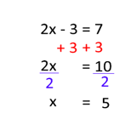  - Engage in problem-solving experiences connected with place, story, cultural practices, and perspectives relevant to local First Peoples communities, the local community, and other cultures | Communicating and Representing (CM)  - Explain and justify mathematical ideas and decisions in many ways  - Represent mathematical ideas in concrete, pictorial, and symbolic forms  - Use mathematical vocabulary and language to contribute to discussions in the classroom  - Take risks when offering ideas in classroom discourse
Reasoning and Analyzing (RA)  - Develop thinking strategies to solve puzzles and play games  - Explore, analyze, and apply mathematical ideas using reason, technology, and other tools  - Estimate reasonably and demonstrate fluent, flexible, and strategic thinking about number  - Model with mathematics in situational contexts  - Think creatively and with curiosity and wonder when exploring problems  Anna and Bob go walking in the snow. Anna walks 1 3/5 km. Bob walks 2 ½ more km than Anna. What is the total distance that they walked? | Connecting and Reflecting (CR)  - Reflect on mathematical thinking  - Connect mathematical concepts with each other, with other areas, and with personal interests  - Use mistakes as opportunities to advance learning  - Incorporate First Peoples worldviews, perspectives, knowledge,  and practices to make connections with mathematical concepts

Evaluation of the curricular competencies will be provided using this proficiency scale:
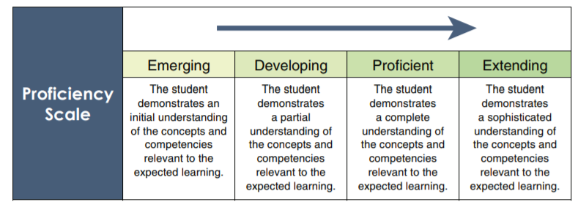
In this way, students receive more specific feedback on their progress in each area.

The term and final grade will be determined based on converting the proficiency scale achievement in the 4 curricular competancies to a percentage using the conversion table below (subject to change).

Frequency | EMERGING (E) | DEVELOPING (D) | PROFICIENT (P) | EXTENDING (X)
Almost Always | 57% | 70% | 88% | 98%
Most Often | 53% | 65% | 82% | 95%
More than Not | 50% | 60% | 76% | 92%
If you do not show enough evidence to be given an “Emerging” proficiency, then “Insufficient Evidence (IE)” will be given. Frequent IE achievement will result in the student failing the course.

Assigned Work
- Assignments: Each class, there is a math assignment to help you practice and develop understanding.
- It is YOUR responsibility to attempt every problem, check your work, and ask questions about anything you don’t understand. Check the answer keys, ask your teacher or your friends, or get extra help outside of class time. Remember, the more you practice, the stronger the neural connections you’ll make!
- If absent, you are still responsible for work assigned on days you were absent. If absent, check with a classmate and/or my website (mkamber.weebly.com) for assigned work, or email me.
- These assignments will NOT be graded since research shows that often leads to copying and students need to be self-motivated to learn BUT there is a direct correlation between completing math problems and student success! To do well, you MUST be prepared to DO WORK IN CLASS and AT HOME REGARDLESS IF IT IS FOR MARKS OR NOT! Be prepared to hand in your work at the start of class on the day of the test, even if it is not going to be marked.
- Journal prompts: There is also a journal prompt to be answered each day. These are due on the day of the Unit Test (at start of class). Late Journal Prompts will not be accepted. These contribute to your Communicating and Representing (CM) and Connecting and Reflecting (CF) competencies.
- This course moves quickly: You cannot put off the homework for a specific topic and still expect to be able to move on with the next lesson. Please do not fall behind!

What is Flex Time (a.k.a. Math Madness)?!? This is a designated time when you are encouraged to come for help and/or work on your assignments! We meet in my classroom (Mon-Thurs 8:40-9:05). Stay as long as you like.

Expectations
- RESPECT people, property, and yourself.
- Behave maturely towards everyone in the class.
- Work hard and be kind. Be prepared to work with others and for changes in seating.
- Keep a growth mindset. (Believe in your math abilities!)
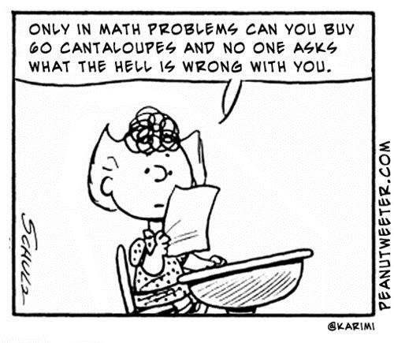
- Keep cell phones and listening devices away unless instructed by the teacher.
- We do math (& puzzles) for the whole block!
- If you are absent, you must bring a valid note from a parent/guardian. Students are expected to check their assignments package for details of assigned work and to be up-to-date on material when they return.
- Use class time wisely to complete work and ask for permission if you need to leave the room and return as soon as possible.
- Try your best but ask for help. Come to Flex Time!

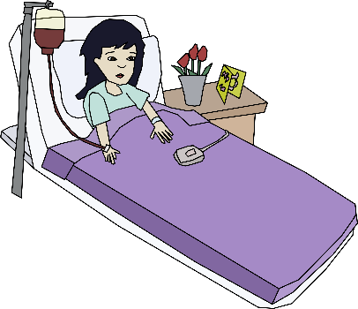
Policy on Absences for Unit Tests

- DO NOT MISS A TEST.
- If a student knows that they will be absent on the day of an upcoming test, they must make prior arrangements with the teacher to write the test at another time.
- If a student misses a unit test, a parent or guardian must phone or email the teacher on the day of the test, excusing the student from the test on that day. A day to write the test will be arranged.
- If all other cases, students will have to wait for a make-up day towards the end of the term to write the test.
- Being nervous or unprepared for a test is not a valid reason for absence on the day of the test.

Honesty Policy and Test-Taking Procedure
- Cell phones at the front of the class.
- Be prepared for assigned seating.
- No electronic devices.
- No talking or communication with classmates.
- No notes or extra paper.
- Eyes on your own paper.
- No sharing of supplies/information.
- Put your hand up if you have a question.
- Bring your silent reading book for when you're done or try a puzzle or colouring activity.
10. Any cheating on assignments, tests, quizzes, or exams will result in “IE – Insufficient Evidence”. No rewrites will be permitted. A meeting with your parents/guardians and administrator will occur.

Never, never, never give up!
“If you think you can, or you think you can’t, you are right!” – Henry Ford

