Name: _______________________
“This Can Make You Rich” Math Assignment (Math 11)
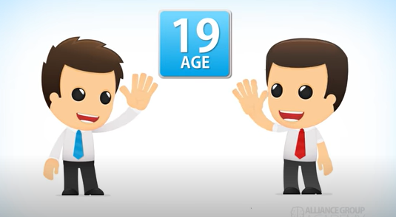
Mathematicians, I’ve saved the best for last. I believe the first video below is the most important thing you can learn in high school!! That’s a big claim but following its advice can make a huge difference in your life. It can help you become a millionaire.
Part 1: Compound vs Simple Interest
Watch the short video “Need to Invest Early” https://youtu.be/5beqHhziyhs. Answer the following questions.
1. Fill out the chart. (You may need to rewind the video a few times.)
 | Larry | Barry
Age he started investing
Interest Rate
Amount he invested per year
Number of years he made regular deposits
Total amount he invested (without interest)
Amount at age 65 (with interest)

2. Who ended up with more money at the retirement age of 65?

3. Explain, giving 2 reasons why that person ended up with more money.

TURN THE PAGE for Part 2: OPPORTUNITY COST ---
Part 2: Opportunity Cost
1. Watch the video https://youtu.be/ggTqyz9u6oE and use it to answer the following.
Amount (SHOW the CALCULATIONS involved to get the amounts)
How much does the guy spend a day?
How much is that per month (counting 30 days per month)?
How much is that a year?
How much is that in 20 years?

2. At the end of the video, the guy makes a joke, but the girl has a valid point! The amount of money you save by NOT spending it is called opportunity cost.
NOTE: For this part of the assignment, if you do not have an item that you purchase regularly, make one up!
- What is an item you buy regularly (for example, it could be a bubble tea, fries, chips, etc.)?

- How much does that item cost?

- How often do you buy the item per month?

- How much does that add up to per month?

- How much money would that add up in a year?

- How much is that in 20 years?
Note that the money you would have saved by not buying that item would be even greater than the amount in f) because of compound interest!

