Name: Shopping for a Car Assignment
Many students dream of owning their own car. Here is a chance for you to practice what you need to know for the day when you purchase your first car! Watch the “What You NEED to Know When Buying Your First Car!” video at https://youtu.be/y568cjRQsoM first before starting this assignment.
- Your Salary:
Age I want to buy a car: ____________ My annual salary: $____________ (see video; choose average or median)
I qualify for a car loan that is 2 times my salary, which works out to: $______________
My monthly budget (take salary, divide by 12 months, multiply by 0.10 or 10%): $___________

- Vehicle Search: Find 2 possible used cars you could reasonably afford at https://www.autotrader.ca/ or https://vancouver.craigslist.org/d/cars-trucks/search/cta. (International students who have left Burnaby can use the school’s postal code, V5J 2B7, or do research in their own city.)

Fill out this table, e.g., 2017 Honda Civic, 24 055 km, $15 250, 6.99% etc.
Car | Year of Car | Car Company | Model | Mileage (in km) | Price | Financing Interest  Rate (APR)  (see below) | Wholesale Price  (see step 3) | Retail Price  (see step 3) | What % of the retail price is the price?  = Price/Retail x 100
1.
2.

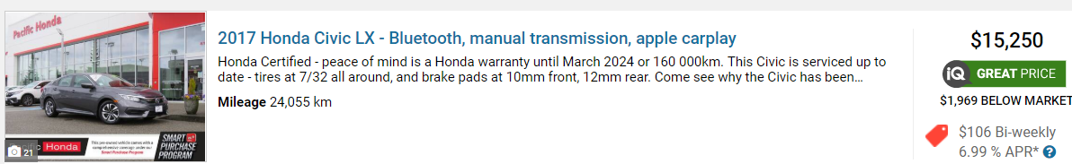
Include screenshots and price of each car, e.g.,

IMPORTANT: The financing interest rate was not discussed in the video, but we need it for our next assignment to figure out the details of your loan. In the above example, it is 6.99%. APR stands for Approved Percentage Rate (the interest rate).
- Check the pricing of each car: Are you getting a good deal, or are you getting ripped off?! Go to http://www.vmrcanada.com/ and look up both the wholesale price and the retail price of each car. Enter these values in the table above.

- Check the reliability of each car: Go to Consumer Reports for cars https://www.consumerreports.org/cars-. What are the ALERTS for each of your potential cars?
Car | Number of Alerts | Brief Words Describing each Alert (list a MAXIMUM of 2 concerns with each car), e.g., airbag, steering, etc.
Car 1
Car 2

- Check the history of each car: This is a vital step when buying a used car! Checking a car’s history can save you from paying too much for a vehicle that has been damaged or has a shady past. Because Vehicle History Report costs money, you are not asked to buy reports. However, to help you learn and remember about this step for when you actually may need it one day, do the following: Go to Carfax https://www.carfax.ca/ and follow my video’s instructions to “View a Sample Report.” Answer the following:

- Has the vehicle been in an accident? Y/N_____ If yes, what was the Accident/Damage estimate? $___________
What was the mileage (odometer) when the accident occurred? $_________
- Under Canadian Registration, in what provinces has the vehicle been registered?
___________________ and _________________.
- Was a lien found? __________
- Was the vehicle ever reported stolen? __________

- Car Mechanic check: Provide the business address of a local mechanic or garage HERE:

Congratulations! You’ve followed the 6 steps for buying a car. Next time we’ll look at the TRUE cost of the car. (It will start to lose value the moment you buy it!)

